Experiment 3

Aim: - To create a simple client-server communication using TCP/IP protocol.

Steps for server: -

1. We import socket module which helps in establishing the client/server communication.
2. We specify the protocol type, TCP in our case.
3. We bind the port address of client with server using bind function.
4. We listen till the connection is established.
5. When it is established we receive the message from the client using recv with max 1024 bytes.
6. We ask the user to enter a message which he wants to send to client.
7. We close the server connection.

Steps for Client: -

1. We import socket module which helps in establishing the client/server communication.
2. We specify the protocol type, TCP in our case.
3. We connect the port address of server with client using connect function.
4. We ask the client to enter a message which he wants to send to user.
5. We send the message to the server using send. We receive and decode the function.

Code for server :-

**import** socket  
  
s=socket.Socket()  
  
s.bind((**"Localhost"**,9999))  
s.listen(5)  
print(**"Waiting..."**)  
  
**while True**:  
 c,addr=s.accept()  
  
 n=c.recv(1024).decode()  
 print(**"Connected with"**,addr,n)  
 p=input(**"Enter Message:"**)  
 c.send(bytes(p,**'utf-8'**))  
  
 c.close()

Code for Client:-

**import** socket  
c=socket.socket()  
  
c.connect((**'localhost'**,9999))  
n=input(**"Enter Name:"**)  
c.send(bytes(n,**'utf-8'**))  
print(c.recv(1024).decode())

Console Snapshots:-

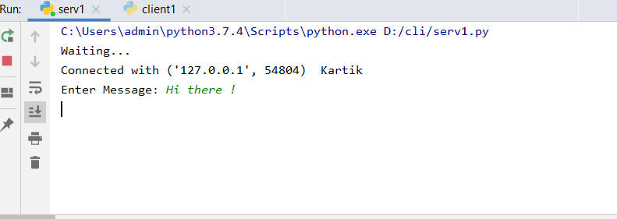1)Server Console : -

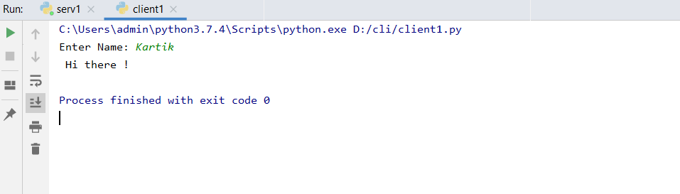2)Client Console : -

Result : - The client/server TCP communication was successfully established.